SSC (School Site Council) Meeting
May 04, 2021
Tierrasanta Elementary School
Minutes
Join Zoom Meeting
https://sandiegounified.zoom.us/j/86718156626
Meeting ID: 867 1815 6626
Dial by your location
+1 669 219 2599 US (San Jose)
+1 669 900 6833 US (San Jose)
Meeting ID: 867 1815 6626
Find your local number: https://sandiegounified.zoom.us/u/kcWXVdi0lT

Call to order (attendance): Present- Bledsoe, Viavada, Krause, Noonan, Freitas, Milder, Wilson, Reynolds
Public comment: None
Old Business: Review and Approve previous meeting minutes-Minutes from 2/22/21 approved
New Business:

Proposed Budget Transfers
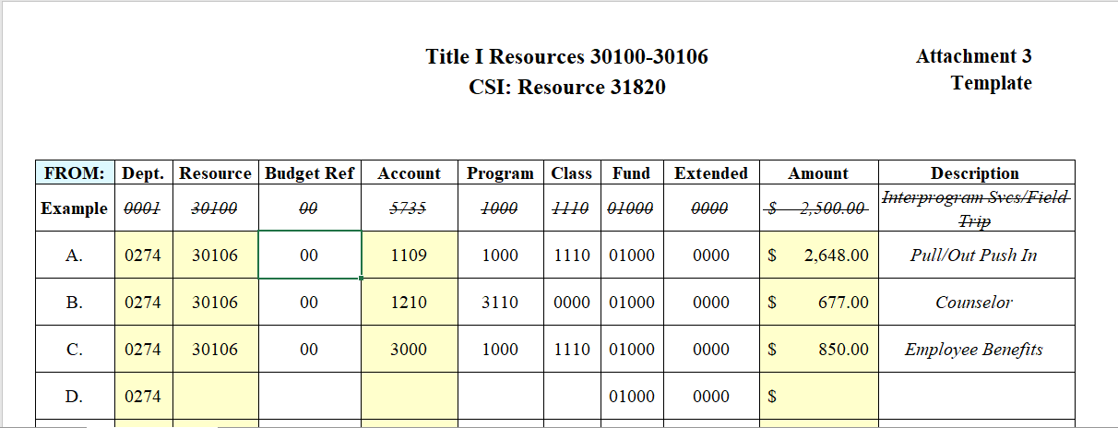

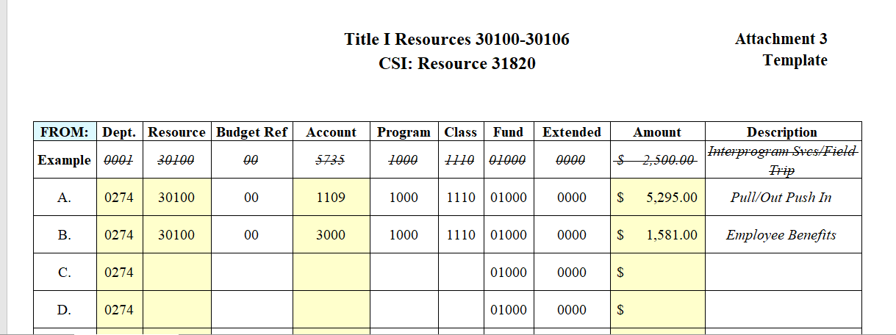

Review and Analysis of Student Achievement data and site plan strategies:
Data Review: DRA: 62% at or above grade level on first test, 70% at or above on 2nd test (slightly lower than previous years). FAST (2nd-5th grade): Reading-19 students at high risk, 41 some risk. Math-15 students high risk, 36 some risk. Discussion of test-taking at home vs. on-site and the various factors that may impact scores (parents assisting children, children quickly clicking through questions without supervision, learning loss, etc…). Students will be tested once more in-person.

Benefits to Students: Discussion of realignment of unused resources which were intended for in-person learning. Budget will be transferred to cover additional tutoring and testing costs incurred in phase 1 as well as Software licenses for the remainder of this year and into the summer. Budget will also be used for books and supplies as necessary.

Vote on budget transfers: Approved unanimously.

Title I Parent Involvement Spending Discussion: $1,472.54 in the budget. Proposal to spend an amount not to exceed $1000 on a Parent Education/Appreciation and summer materials pickup drive-thru event for all families. The remainder will be spent on colored paper, white paper, and cardstock for parent communication.

Vote on Parent involvement spending: Approved unanimously.

Items for next agenda:
Round Table
Adjourn

SGT Meeting
May 4, 2021
Tierrasanta Elementary School
AGENDA
Call to order
Old Business:
Public Comment:
New Business

- Wellness Committee
- Running Club (ongoing)
- Staff wellness Step Challenge and fitness challenge complete

Round Table
Agenda items for next meeting

Meeting adjourned.

